**Angles Worksheet – Diagrams are not drawn accurately!**

**A)** Work out the missing angles – show your working clearly. 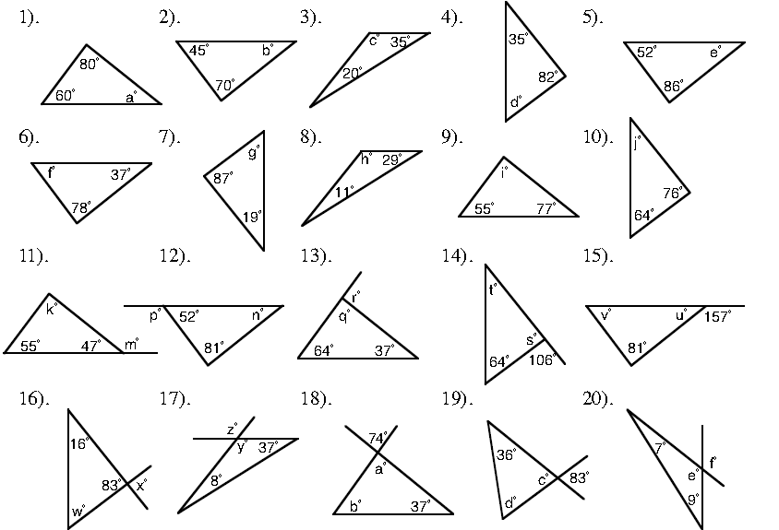

**B)** Work out the missing angles – show your working clearly.

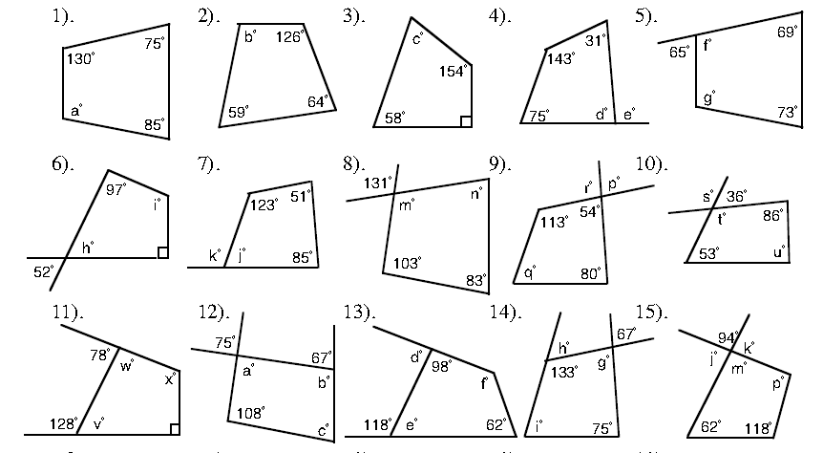

**C)** Work out the missing angles – show your working clearly.

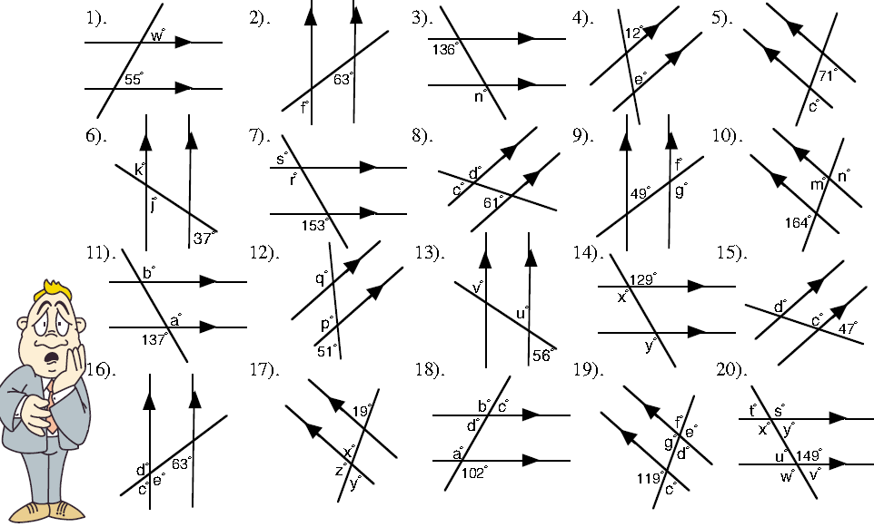

**D)** Finished everything? Try this angle challenge ☺

